**VAGA TRIP**

**A Project Report Submitted by**

**Utsav Dharmendrabhai Gohel – 91900104011**

**in partial fulfillment for the award of the degree of**

**Bachelor of Technology**

**in**

**Information Technology**



**Faculty of Technology**

**Marwadi University, Rajkot**

**2022-23**



**Faculty of Technology**

**Marwadi University**

Department of Information Technology

**2022-23**

**CERTIFICATE**

This is to certify that the project entitled **Vaga Trip** has been carried out by **Utsav Dharmendrabhai Gohel** **- 91900104011** under my guidance in partial fulfillment of the degree of Bachelor of Technology in Information Technology of Marwadi University, Rajkot during the academic year 2022-23.

**Date: ____________________**

**Internal Guide Head of the Department**

Prof. Yatri Davda Dr. Damodharan Palaniappan

Assistant Professor

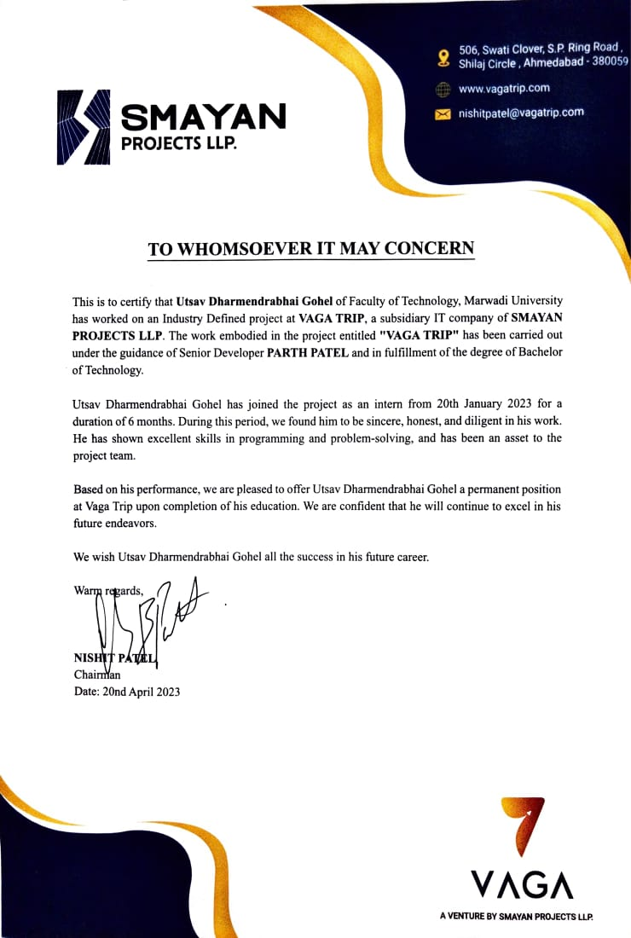

**Plagiarism Certificate**

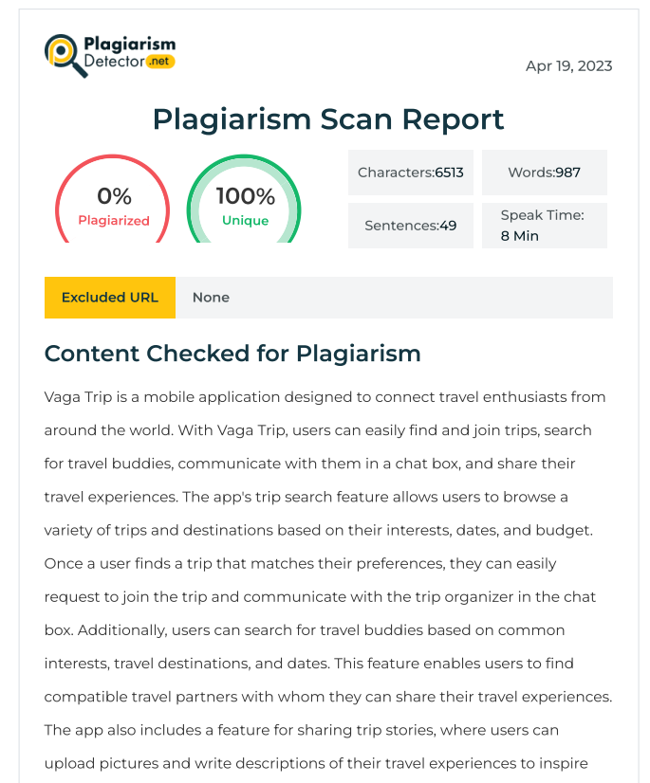

**Undertaking about Originality of Work**

This is to certify that this project report submitted by the team members is an outcome of our independent and original work. I have acknowledged all the sources from which the idea and extracts have been taken. The project is free from any plagiarism and has not been submitted elsewhere.

**Acknowledgments**

I would like to take this opportunity to express my gratitude to all those who have supported and contributed to the completion of this final year project.

Firstly, I would like to thank my project mentor **Ms. Yatri Davda** for her unwavering guidance, support, and invaluable feedback throughout the project. Her expertise and knowledge in the field helped me to stay on track and achieve the goals of this project.

I am also grateful to our industry project guide **Mr.** **Parth Patel**, Senior Developer at Vaga Trip for sharing his expertise and knowledge about the travel industry, and providing us with the necessary industry insights and feedback. His inputs and suggestions helped us to make this project more relevant and practical.

I would also like to thank my family and friends for their constant support, motivation, and encouragement throughout the project. Their unwavering support helped me stay focused and motivated during challenging times.

Finally, I would like to extend my gratitude to the Marwadi University, who have given me chance to do research and implementation for this project.

Thank you all for your support and encouragement.

**Index**

|  |  |  |
| --- | --- | --- |
|  | **Institute’s Vision and Mission……………………………………………** | **vii** |
|  | **Department’s Vision and Mission………………………………………..** | **ix** |
|  | **PEO, POs and PSOs ……………………………………………………...** | **x** |
|  | **Abstract……………………………………………………………………** | **Xii** |
|  | **List of Figure……………………………………………………………..** | **Xiii** |
|  | **List of Table……………………………………………………………….** | **Xiv** |
|  |  |  |
| **1.** | **Introduction……………………………………………….........................** | 1 |
| 1.1 | Problem Summary and Introduction………………………………………. | 2 |
| 1.2. | Aim and Objectives………………………………………………………... | 2 |
| 1.3 | Problem Specifications……………………………………………………. | 3 |
| 1.4 | Literature Review and Prior Art Search ………………………………….. | 4 |
| 1.5 | Plan of the work…………………………………………………………… | 6 |
| 1.6 | Materials / Tools required…………………………………………………. | 7 |
| **2.** | **Analysis, Design Methodology and Implementation Strategy…………** | 8 |
| 2.1 | Observation Matrix………………………………………………………... | 8 |
| 2.2 | Ideation Canvas…………………………………………………………… | 9 |
| 2.3 | Product Development Canvas……………………………………………... | 11 |
| 2.4 | System Design……………………………………………………………... | 13 |
| **3** | **Implementation**………………………………………………………....... | 19 |
| 3.1 | Implemented Functionality…..……………………………………………. | 19 |
| 3.2 | Results and Reports……………………………………………………….. | 19 |
| 3.3 | Snapshots…………………………………………………………………... | 24 |
| 3.4 | Testing and Verification…………………………………………………… | 30 |
| **4** | **Conclusion………………………………………………………………...** | 32 |
| 4.1 | Summary of the results…………………………………………………….. | 32 |
| 4.2 | Advantages of your work/results/methodologies………………………….. | 32 |
| 4.3 | Scope of future work………………………………………………………. | 33 |
| 4.4 | Unique Features of your Innovation/Project (Industry/Project)…………… | 34 |
|  |  |  |
| ● | References ……………………………………………….………………... | 36 |

**Institute’s Vision and Mission**

**Institute’s Vision**

To foster an environment that empowers people, organisations and societies through education, ideas, research and training.

**Institute’s Mission**

* To provide quality education and thereby bring social transformation.‎ ‎‎‎
* ‎ To create leaders through innovation and entrepreneurship.‎ ‎‎‎
* ‎ To cultivate the culture of research advancements.‎ ‎‎‎
* ‎ To imbibe universal consciousness.‎ ‎‎
* ‎ To stimulate growth through industrial and international partnerships.‎

**Department’s Vision and Mission**

**Department’s Vision**

To be recognized as a team delivering educational excellence that advances teaching, learning, and research, in alignment with Marwadi Education Foundation's mission and goals.

**Department’s Mission**

* To impart knowledge and skills related to the undergraduate program offered by the department.
* To impart technical and professional skills to make graduates competitive and capable.
* To constantly encourage and motivate graduates for innovation, entrepreneurship Industry readiness.
* To inspire graduates for higher education and research and to place graduates in leading industries and companies.

**PEO, PO, and PSO**

**Program Educational Objectives (PEO):**

Our graduated students are expected to fulfill the following Program Educational Objectives (PEOs):

1. **Core Competency:** Successfully apply fundamental mathematical, scientific, and engineering principles in formulating and solving engineering and real life problems for betterment of society.
2. **Breadth:** Will apply current industry accepted practices, new and emerging technologies to analyse, design, implement and maintain state of art solutions.
3. **Professionalism:** Work effectively and ethically in ever changing global professional environment and multi-disciplinary environment.
4. **Learning Environment:** Demonstrate excellent communication and soft skills to fulfil their commitment towards social responsibilities and foster life-long learning.
5. **Preparation:** Promote research and patenting to enhance technical and entrepreneurship skills within them.

**Program Outcomes (POs)**

Engineering Graduates will be able to:

**PO1: Engineering knowledge:** Apply the knowledge of mathematics, science, engineering fundamentals, and an engineering specialization to the solution of complex engineering problems.

**PO2: Problem analysis:** Identify, formulate, review research literature, and analyze complex engineering problems reaching substantiated conclusions using first principles of mathematics, natural sciences, and engineering sciences.

**PO3: Design/development of solutions:** Design solutions for complex engineering problems and design system components or processes that meet the specified needs with appropriate consideration for the public health and safety, and the cultural, societal, and environmental considerations.

**PO4: Conduct investigations of complex problems:** Use research-based knowledge and research methods including design of experiments, analysis and interpretation of data, and synthesis of the information to provide valid conclusions.

**PO5: Modern tool usage:** Create, select, and apply appropriate techniques, resources, and modern engineering and IT tools including prediction and modeling to complex engineering activities with an understanding of the limitations.

**PO6: The engineer and society:** Apply reasoning informed by the contextual knowledge to assess societal, health, safety, legal and cultural issues and the consequent responsibilities relevant to the professional engineering practice.

**PO7: Environment and sustainability:** Understand the impact of the professional engineering solutions in societal and environmental contexts, and demonstrate the knowledge of, and need for sustainable development.

**PO8: Ethics:** Apply ethical principles and commit to professional ethics and responsibilities and norms of the engineering practice.

**PO9: Individual and team work:** Function effectively as an individual, and as a member or leader in diverse teams, and in multidisciplinary settings.

**PO10: Communication:** Communicate effectively on complex engineering activities with the engineering community and with society at large, such as, being able to comprehend and write effective reports and design documentation, make effective presentations, and give and receive clear instructions.

**PO11: Project management and finance:** Demonstrate knowledge and understanding of the engineering and management principles and apply these to one’s own work, as a member and leader in a team, to manage projects and in multidisciplinary environments.

**PO12: Life-long learning:** Recognize the need for, and have the preparation and ability to engage in independent and life-long learning in the broadest context of technological change.

**Program Specific Outcomes (PSOs)**

**PSO1.** Graduates will be able to identify, analyze and solve the real time problems of the industries in the area of software development, embedded system, VLSI design, IoT and communication technologies.

**PSO2.** Graduates will be able to contribute as an analyst and developer in the areas related to cloud computing, DevOps, security, machine learning, artificial intelligence and big data.

**Abstract**

*Vaga Trip is a mobile application designed to connect travel enthusiasts from around the world. With Vaga Trip, users can easily find and join trips, search for travel buddies, communicate with them in a chat box, and share their travel experiences. The app's trip search feature allows users to browse a variety of trips and destinations based on their interests, dates, and budget. Once a user finds a trip that matches their preferences, they can easily request to join the trip and communicate with the trip organizer in the chat box. Additionally, users can search for travel buddies based on common interests, travel destinations, and dates. This feature enables users to find compatible travel partners with whom they can share their travel experiences. The app also includes a feature for sharing trip stories, where users can upload pictures and write descriptions of their travel experiences to inspire and inform other travelers. This feature allows users to share their unique perspectives on destinations, experiences, and cultures. Overall, Vaga Trip provides a comprehensive platform for travel enthusiasts to find new adventures, connect with like-minded travelers, and share their travel experiences.*

**List of Tables**

|  |  |  |
| --- | --- | --- |
| **Table No.** | **Table Description** | **Page No** |
|  |  |  |
| Table 1.5 | Work Breakdown Structure………………………………………. | 6 |
| Table 3.2 | SFS project tracker……………………………………………….. | 20 |
| Table 3.4 | Testing Table …………………………………………………….. | 31 |

**List of Figures**

|  |  |  |
| --- | --- | --- |
| **Figure No.** | **Figure Description** | **Page No** |
|  |  |  |
| Figure 1.1 | Contribution of Travel industry in GDP…………………. | 1 |
| Figure 2.1 | Observation Matrix……………………………………… | 8 |
| Figure 2.2 | Ideation Canvas…………………………………………... | 9 |
| Figure 2.3 | Product Development Canvas……………………………. | 11 |
| Figure 2.4.1 | Use case Diagram………………………………………… | 13 |
| Figure 2.4.2 | DFD (Data Flow Diagram) ……………………………… | 14 |
| Figure 2.4.3 | Activity Diagram…………………………………………. | 15 |
| Figure 2.4.4 | ER Diagram………………………………………………. | 16 |
| Figure 2.4.5(a) | Sequence diagram of Vaga Trip Process………………... | 17 |
| Figure 2.4.5(b) | Sequence daigram of vaga login process………………… | 17 |
| Figure 2.4.6(a) | Class Diagram(a) - Birds Eye View……………………… | 18 |
| Figure 2.4.6(b) | Class Diagram (b)……………………………………….. | 18 |
| Figure 3.3 | Snapshot…………………………………………………. | 24 |